**---------------------------------COSC631 FINAL PROJECT-----------------------------**

**PREPARED BY BENYAM MENGESHA,**

**IKENNA CHUKWUDOZIE,**

**ISSAIAH IDUBOR,**

**JAGADISH MOHNRAM**

**---------------------------------------------creating the xml table----------------------------------------------------------------**

drop table xml_tab;

CREATE TABLE xml_tab (

id NUMBER,

xml_data XMLTYPE

);

**------------------------------inserting the data in the xml table--------------------------------------------------------------**

insert into xml_tab values('1',xmltype('<employee>

<empno>7369</empno>

<ename>SMITH</ename>

<title>CLERK</title>

<hiredate>17-DEC-1980</hiredate>

</employee>'));

**-----------------------------------------for the second row in xml file------------------------------------------**

insert into xml_tab values('2',xmltype('<employee>

<empno>7499</empno>

<ename>ALLEN</ename>

<title>SALESMAN</title>

<hiredate>20-FEB-1981</hiredate>

</employee>'));

**---------------------------------------------for the third row in xml file----------------------------------------------------**

insert into xml_tab values('3',xmltype('<employee>

<empno>7521</empno>

<ename>WARD</ename>

<title>SALESMAN</title>

<hiredate>22-FEB-1981</hiredate>

</employee>'));

**---------------------------------------------------------------for the fourth row in xml file------------------------------**

insert into xml_tab values('4',xmltype('<employee>

<empno>7566</empno>

<ename>JONES</ename>

<title>MANAGER</title>

<hiredate>02-APR-1981</hiredate>

</employee>'));

**------------------------------------for the fifth row in xml file-------------------------------------------------------------**

insert into xml_tab values('5',xmltype('<employee>

<empno>7654</empno>

<ename>MARTIN</ename>

<title>SALESMAN</title>

<hiredate>28-SEP-1981</hiredate>

</employee>'));

**----------------------------------------for the sixth row in xml file-----------------------------------------------------------**

insert into xml_tab values('6',xmltype('<employee>

<empno>7934</empno>

<ename>MILLER</ename>

<title>CLERK</title>

<hiredate>23-JAN-1982</hiredate>

</employee>'));

**---------------------------------------------------show the xml file in the server--------------------------------**

DECLARE

l_xmltype XMLTYPE;

BEGIN

SELECT XMLELEMENT("employees",

XMLAGG(

XMLELEMENT("employee",

XMLFOREST(

e.empno AS "empno",

e.ename AS "ename",

e.title AS "title",

TO_CHAR(e.hiredate, 'DD-MON-YYYY') AS "hiredate"

)

)

)

)

INTO l_xmltype

FROM emp e;

SET LONG 5000

SELECT x.xml_data.getClobVal()

FROM xml_tab x;

X.XML_DATA.GETCLOBVAL()

**--------------------------------------------------------------- XML FILE ------------------------------------------------------**

<employees>

<employee>

<empno>7369</empno>

<ename>SMITH</ename>

<title>CLERK</title>

<hiredate>17-DEC-1980</hiredate>

</employee>

<employee>

<empno>7499</empno>

<ename>ALLEN</ename>

<title>SALESMAN</title>

<hiredate>20-FEB-1981</hiredate>

</employee>

<employee>

<empno>7521</empno>

<ename>WARD</ename>

<title>SALESMAN</title>

<hiredate>22-FEB-1981</hiredate>

</employee>

<employee>

<empno>7566</empno>

<ename>JONES</ename>

<title>MANAGER</title>

<hiredate>02-APR-1981</hiredate>

</employee>

<employee>

<empno>7654</empno>

<ename>MARTIN</ename>

<title>SALESMAN</title>

<hiredate>28-SEP-1981</hiredate>

</employee>

<employee>

<empno>7698</empno>

<ename>BLAKE</ename>

<title>MANAGER</title>

<hiredate>01-MAY-1981</hiredate>

</employee>

<employee>

<empno>7782</empno>

<ename>CLARK</ename>

<title>MANAGER</title>

<hiredate>09-JUN-1981</hiredate>

</employee>

<employee>

<empno>7788</empno>

<ename>SCOTT</ename>

<title>ANALYST</title>

<hiredate>19-APR-1987</hiredate>

</employee>

<employee>

<empno>7839</empno>

<ename>KING</ename>

<title>PRESIDENT</title>

<hiredate>17-NOV-1981</hiredate>

</employee>

<employee>

<empno>7844</empno>

<ename>TURNER</ename>

<title>SALESMAN</title>

<hiredate>08-SEP-1981</hiredate>

</employee>

<employee>

<empno>7876</empno>

<ename>ADAMS</ename>

<title>CLERK</title>

<hiredate>23-MAY-1987</hiredate>

</employee>

<employee>

<empno>7900</empno>

<ename>JAMES</ename>

<title>CLERK</title>

<hiredate>03-DEC-1981</hiredate>

</employee>

<employee>

<empno>7902</empno>

<ename>FORD</ename>

<title>ANALYST</title>

<hiredate>03-DEC-1981</hiredate>

</employee>

<employee>

<empno>7934</empno>

<ename>MILLER</ename>

<title>CLERK</title>

<hiredate>23-JAN-1982</hiredate>

</employee>

</employees>

**------------------------------------------------------end of xml file----------------------------------------------------------------**

**--------------------------display xml file in in in columns and rows---------------------------------------------------------**

DECLARE

l_xmltype XMLTYPE;

BEGIN

SELECT XMLELEMENT("employees",

XMLAGG(

XMLELEMENT("employee",

XMLFOREST(

e.empno AS "empno",

e.ename AS "ename",

e.title AS "title",

TO_CHAR(e.hiredate, 'DD-MON-YYYY') AS "hiredate"

)

)

)

)

INTO l_xmltype

FROM emp e;

INSERT INTO xml_tab VALUES (1, l_xmltype);

COMMIT;

END;

/

**---------------end of the code TO DISPLAY THE XML FILE IN XML FORMAT FFROM THE XML TABLE-----------**

SET LONG 5000

SELECT x.xml_data.getClobVal()

FROM xml_tab x;

**----------------------------------------Show the XML FILE saved in the server---------------------------------------------**

SELECT xt.*

FROM xml_tab x,

XMLTABLE('/employees/employee'

PASSING x.xml_data

COLUMNS

"EMPNO" VARCHAR2(4) PATH 'empno',

"ENAME" VARCHAR2(10) PATH 'ename',

"TITLE" VARCHAR2(9) PATH 'TITLE',

"HIREDATE" VARCHAR2(11) PATH 'hiredate'

) xt;

-**--------------------------------------------------creating SQL TABLE -------------------------------------------------------------** drop table employee;

create table employee (empno varchar2(40),ename varchar2(40),TITLE varchar2(90),hiredate varchar2(50));

**-------------------------------------------end of creating the SQL TABLE-------------------------------------------------------**

**----------------------------PROCUDERE FOR INSERTING THE XML FILE IN THE SQL TABLE----------------------------**

CREATE OR REPLACE PROCEDURE INSERT_INSQLTableFromXMLFile is

cursor c1 is select x.xml_data from xml_tab x;

r xmltype;

BEGIN

Open c1;

Loop

fetch c1 into r;

exit when c1%notfound;

insert into employee VALUES(r.extract('/employee/empno/text()'),r.extract('/employee/ename/text()'),r.extract('/employee/title/text()'),r.extract('/employee/hiredate/text()'));

End loop;

Close c1;

END;

/

**------------------------------------------------------------------------------------------------------------------------------------------**

**========================SECOND TABLE AND ITS FUNCTIONS==============================**

drop table xml_tab_3;

CREATE TABLE xml_tab_3 (

id NUMBER,

xml_data XMLTYPE

);

**------------------------------inserting the date in the xml_tab_3 table----------------------------------------------------**

insert into xml_tab_3 values('1',xmltype( '<customer>

<CUSTNO>A1234</CUSTNO>

<FNAME>Jones</FNAME>

<LNAME>John</LNAME>

<ADDRESS>123 MAIN ST</ADDRESS>

<CITY>LARGO</CITY>

<STATE>MD</STATE>

<ZIPCODE>20745</ZIPCODE>

<PHONE>301-123-4567</PHONE>

</customer>'));

---------for the second row in xml file------

insert into xml_tab_3 values('1',xmltype( '<customer>

<CUSTNO>A12233</CUSTNO>

<FNAME>Smith</FNAME>

<LNAME>ben</LNAME>

<ADDRESS>234 Elm St</ADDRESS>

<CITY>Lanham</CITY>

<STATE>MD</STATE>

<ZIPCODE>20745</ZIPCODE>

<PHONE>301-123-4560</PHONE>

</customer>'));

-----------------------------**---------for the third row in xml file------**

insert into xml_tab_3 values('1',xmltype( '<customer>

<CUSTNO>A1456</CUSTNO>

<FNAME>alex</FNAME>

<LNAME>John</LNAME>

<ADDRESS>289 Maria St</ADDRESS>

<CITY>bowie</CITY>

<STATE>MD</STATE>

<ZIPCODE>20904</ZIPCODE>

<PHONE>301-123-4560</PHONE>

</customer>'));

**------------------------------------for the fourth row in xml file------**

insert into xml_tab_3 values('1',xmltype( '<customer>

<CUSTNO>B1678</CUSTNO>

<FNAME>selam</FNAME>

<LNAME>lemma</LNAME>

<ADDRESS>268 st.Luois</ADDRESS>

<CITY>new york</CITY>

<STATE>Ca</STATE>

<ZIPCODE>20745</ZIPCODE>

<PHONE>301-123-4560</PHONE>

</customer>'));

**----------------------------------for the fifth row in xml file------**

insert into xml_tab_3 values('1',xmltype( '<customer>

<CUSTNO>c3567</CUSTNO>

<FNAME>benyam</FNAME>

<LNAME>mengesha</LNAME>

<ADDRESS>4567 winterthur ln.</ADDRESS>

<CITY>silver spring</CITY>

<STATE>MD</STATE>

<ZIPCODE>20904</ZIPCODE>

<PHONE>301-123-4560</PHONE>

</customer>'));

**---------for the sixth row in xml file------**

insert into xml_tab_3 values('1',xmltype( '<customer>

<CUSTNO>A1234</CUSTNO>

<FNAME>brown</FNAME>

<LNAME>John</LNAME>

<ADDRESS>123 MAIN ST</ADDRESS>

<CITY>addis ababa</CITY>

<STATE>MD</STATE>

<ZIPCODE>20745</ZIPCODE>

<PHONE>301-123-4567</PHONE>

</customer>'));

=============================================================================

**--------------------------------------------------creating second SQL TABLE ---------------------------------------------------**

drop table customer;

create table customer(custno varchar2(20),fname varchar2(20),lname varchar2(20),address varchar2(20),city varchar2(20), state varchar2(20),zipcode varchar2(20),phone varchar2(20));

**-----------------------------------------------end of creating the SQL TABLE---------------------------------------------------**

**--------------------------------PROCUDERE FOR INSERTING THE XML FILE IN THE SQL TABLE------------------------**

CREATE OR REPLACE PROCEDURE INSERT_INSQLTableFromXMLFile2 is

cursor c1 is select x.xml_data from xml_tab_3 x;

r xmltype;

BEGIN

Open c1;

Loop

fetch c1 into r;

exit when c1%notfound;

insert into customer VALUES(r.extract('/customer/custno/text()'),r.extract('/customer/fname/text()'),r.extract('/customer/lname/text()'),r.extract('/customer/address/text()'),r.extract('/customer/city/text()'),r.extract('/customer/state/text()'),r.extract('/customer/zipcode/text()'), r.extract('/customer/phone/text()'));

End loop;

Close c1;

END;

/

**----------------------EXCUTING THE PROCEDURE TO INSERT ALL XML FILE IN THE SQL TABLE----------------------**

EXEC INSERT_INSQLTableFromXMLFile2;

**===============================for checking the customer file============================**

select * from customer;

**------------------------------------------to SEE WHAT IS IN the xml_tab_3 file-------------------------**

SELECT x.xml_data.getClobVal()

FROM xml_tab_3 x;

**----------------------------the xml_tab_3 file---------------------------------------**

<customers>

<customer>

<CUSTNO>A1234</CUSTNO>

<FNAME>Jones</FNAME>

<LNAME>John</LNAME>

<ADDRESS>123 MAIN ST</ADDRESS>

<CITY>LARGO</CITY>

<STATE>MD</STATE>

<ZIPCODE>20745</ZIPCODE>

<PHONE>301-123-4567</PHONE>

</customer>

<customer>

<CUSTNO>A12233</CUSTNO>

<FNAME>Smith</FNAME>

<LNAME>ben</LNAME>

<ADDRESS>234 Elm St</ADDRESS>

<CITY>Lanham</CITY>

<STATE>MD</STATE>

<ZIPCODE>20745</ZIPCODE>

<PHONE>301-123-4560</PHONE>

</customer>

<customer>

<CUSTNO>A1456</CUSTNO>

<FNAME>alex</FNAME>

<LNAME>John</LNAME>

<ADDRESS>289 Maria St</ADDRESS>

<CITY>bowie</CITY>

<STATE>MD</STATE>

<ZIPCODE>20904</ZIPCODE>

<PHONE>301-123-4560</PHONE>

</customer>

<customer>

<CUSTNO>B1678</CUSTNO>

<FNAME>selam</FNAME>

<LNAME>lemma</LNAME>

<ADDRESS>268 st.Luois</ADDRESS>

<CITY>new york</CITY>

<STATE>Ca</STATE>

<ZIPCODE>20745</ZIPCODE>

<PHONE>301-123-4560</PHONE>

</customer>

<customer>

<CUSTNO>c3567</CUSTNO>

<FNAME>benyam</FNAME>

<LNAME>mengesha</LNAME>

<ADDRESS>4567 winterthur ln.</ADDRESS>

<CITY>silver spring</CITY>

<STATE>MD</STATE>

<ZIPCODE>20904</ZIPCODE>

<PHONE>301-123-4560</PHONE>

</customer>

</customers>

**----------------------------end of the xml_tab_3 file-----------------------------**

**----------------------EXCUTING THE PROCEDURE TO INSERT ALL XML FILE IN THE SQL TABLE---------------------**

EXEC INSERT_INSQLTableFromXMLFile;

=======================CREATING XML FILE--------------------------------------

drop table xml_tab_4;

CREATE TABLE xml_tab_4 (

id NUMBER,

xml_data XMLTYPE

);

------------------------DEPARTMENT XML FILE

insert into xml_tab_4 values('1',xmltype( '<DEPARTMENT>

<DEPT>

<DID>D1</DID>

<DNAME>IT</DNAME>

<DMANAGER>FRANK BROWN</DMANAGER>

</DEPT>

</DEPARTMENT>'));

---------------------------

insert into xml_tab_4 values('1',xmltype( '<DEPARTMENT>

<DEPT>

<DID>D2</DID>

<DNAME>SOCIAL SCIENSE</DNAME>

<DMANAGER>BOB TOE</DMANAGER>

</DEPT>

</DEPARTMENT>'));

---------------------------============================================

insert into xml_tab_4 values('1',xmltype('<DEPARTMENT>

<DEPT>

<DID>D3</DID>

<DNAME>ECONOMIC</DNAME>

<DMANAGER>ALBERT BROKE</DMANAGER>

</DEPT>

</DEPARTMENT>'));

---------------------------===============================

insert into xml_tab_4 values('1',xmltype('<DEPARTMENT>

<DEPT>

<DID>D4</DID>

<DNAME>MUSIC</DNAME>

<DMANAGER>FRANK BROWN</DMANAGER>

</DEPT>

</DEPARTMENT>'));

--------------------------------------------------------------------------------------------------------------------------------

insert into xml_tab_4 values('1',xmltype('<DEPARTMENT>

<DEPT>

<DID>D5</DID>

<DNAME>MATH</DNAME>

<DMANAGER>JAMES BOND</DMANAGER>

</DEPT>

</DEPARTMENT>'));

--=============================CREATING SQL TABLE-----------------------------------------

drop table DEPART;

create table DEPART(DID varchar2(40),DNAME varchar2(40),DMANAGER varchar2(40));

--================================END OF XML FILE================================

----SHOW THE VALUES OF THE XML_4 FILE

SELECT x.xml_data.getstringVal()

FROM xml_tab_4 x;

------PROCEDURE FOR INSERTING THE XML FILE INTO THE SQL TABLE-============================

CREATE OR REPLACE PROCEDURE INSERT_INSQLTableFromXMLFile4 is

cursor c1 is select x.xml_data from xml_tab_4 x;

r xmltype;

BEGIN

Open c1;

Loop

fetch c1 into r;

exit when c1%notfound;

insert into DEPART VALUES(r.extract('/DEPARTMENT/DEPT/DID/text()'),

r.extract('/DEPARTMENT/DEPT/DNAME/text()'),r.extract('/DEPARTMENT/DEPT/DMANAGER/text()'));

End loop;

Close c1;

END;

/

----------------------EXCUTING THE PROCEDURE TO INSERT ALL XML FILE IN THE SQL TABLE---------------------------------

EXEC INSERT_INSQLTableFromXMLFile4;

--SHOW THE XML FILE FIELDS ARE INSERTED IN THE SQL TABLE--------

SELECT * FROM DEPART;

**---------TO CHECK THE INSERTED ATTRIBUTES FROM THE XML FILE TO THE SQL TABLE EMPLOYEE-------**

THE XML FILE OUTPUT

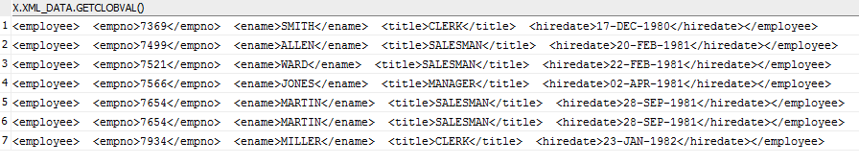

**----------------------------OUTPUT FOR (SELECT * FROM EMPLOYEE;)----------------------------------------------**

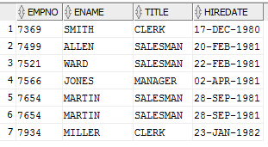

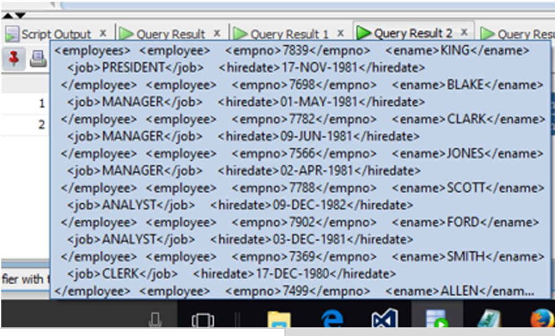

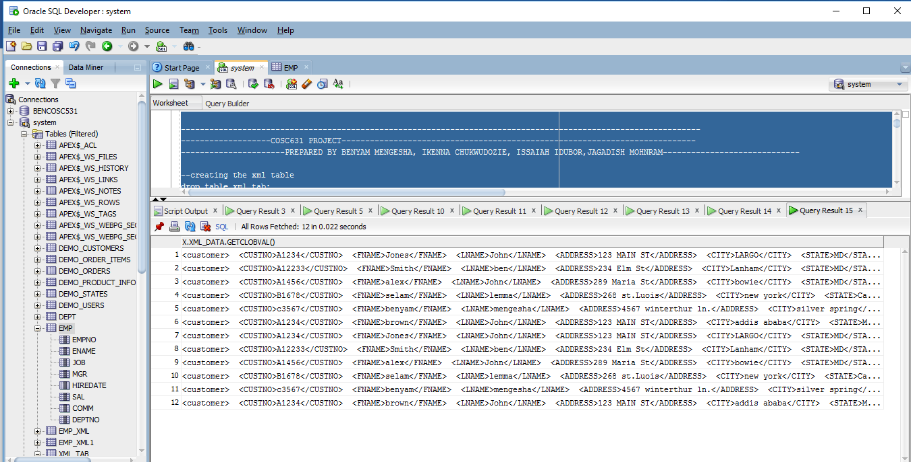

THE XML FILE --- XML_4

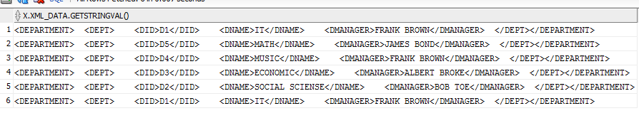

THE THRID TABLE AFTER INSERTING ELEMNTS FROM THE XML FILE

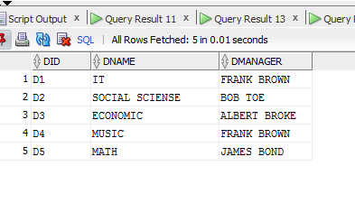

**==================================end of the project====================================**